2006 Extension 1 Term 4
QUESTION ONE MARKS

(a) | (i) Find 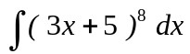. |  | 1
 | (ii) Use the substitution u = 3 - x to find 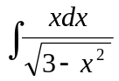. |  | 2
(b) | Express 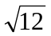sin x + 2cos x in the form of Acos(x + ); where A0 and 0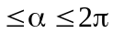. |  | 3
(c) | (i) | By using one application of Simpson’s Rule ( i.e. 3 function values),  find an approximation for the area bounded by y =, 1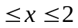,  and the x axis, leaving your answer as a fraction in simplest terms. | 2
 | (ii) | Using integration, find an expression for the exact area in part (i). | 1
 | (iii) | Using your answers to parts (i) and (ii) above , find an approximation  for e correct to 4 decimal places. | 1
QUESTION TWO

(a) | Differentiate tan(x). |  | 1
(b) | (i) | Differentiate 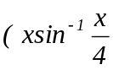 + 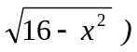 and simplify. | 3
 | (ii) | Hence evaluate 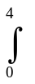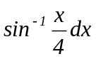. | 2
(c) | (i) | Given that (0,0) is the only stationary point of y = xsin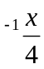,  justify whether it is a minimum or maximum turning point. | 2
 | (ii) | Hence , or otherwise, sketch the curve y = xsin. | 2
QUESTION THREE MARKS

(a) | If x = a + b and y = a - b,
 | (i) | Show that cos x + cos y = 2 cos(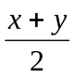) cos(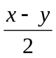). | 2
 | (ii) | Hence find the general solutions to  cos 4 + cos 3 + cos 2 + cos = 0. | 4
(b) | The region in the first quadrant bounded by the curve y = 2tanx and 4  the y-axis between y = 0 and y = is rotated through one complete  revolution about the y-axis. Find the exact volume of the solid of  revolution so formed.
QUESTION FOUR
(a) | Evaluate 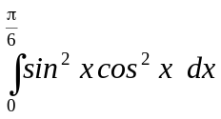. 3
(b) | A function is defined as f(x)= 1 - cos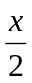 , where 0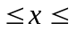a. 2
 | (i) | Find the largest value of a for which the inverse function f(x) exists.
 | (ii) | Find the equation of f(x). 1
 | (iii) | Sketch the graph of y = f(x). 2
 | (iv) | Find the area enclosed between the curve y = f(x), the x-axis and x = 2. 2

QUESTION FIVE MARKS
(a) Find the value of lim 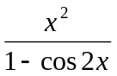 3
X 0

(b) 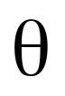
M
N
1
2
P
.O
Y
X
4
4
Not to scale

The diagram shows the part of the circle x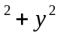= 16 that lies in the first quadrant. The point P( x, y ) is on the circle with centre at the origin O.
M is on the x-axis at x = 2 and N is on the y -axis at y = 1.
The size of angle MOP is radians.

(i) Show that the area, A, of the quadrilateral OMPN is given by  A = 4sin + 2cos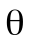. |  |  | 2
(ii) Find the value of tan for which A is maximum. |  |  | 3
(iii) Hence determine in surd form the coordinates of P for which A is  maximum. |  |  | 2
QUESTION SIX MARKS

 | The straight line y = mx + b meets the parabola x= 4ay at the points P(2ap, ap) and Q(2aq, aq).
 | (i) | Find the equation of the chord PQ and hence, or otherwise, show that pq = 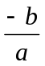. | 3
 | (ii) | Prove that p+ q= 4m+ 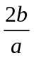. | 2
 | (iii) | Given that the equation of the normal to the parabola at P is  x + py = 2ap + ap  and that N, the point of intersection of the normals at P and Q, has co-ordinates 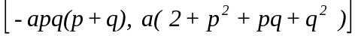,  express these co-ordinates in terms of a, m, b. | 2
 | (iv) | Suppose that the chord PQ is free to move while maintaining a fixed gradient. Find the locus of N and show that this locus is a straight line.  Verify that this line is a normal to the parabola. | 3
 |  | END OF PAPER

